MODULE PYTHON ASSIGNMENT-1

1.Write a python program to test a given number is prime or not.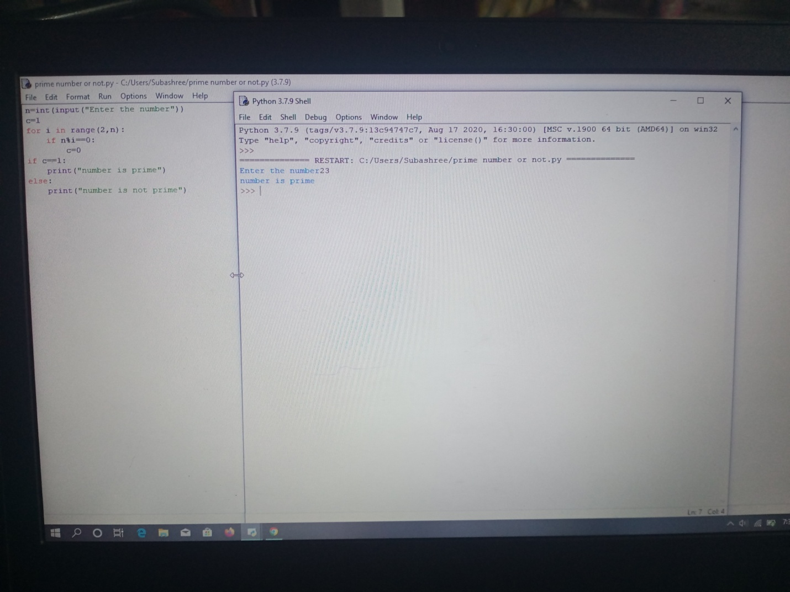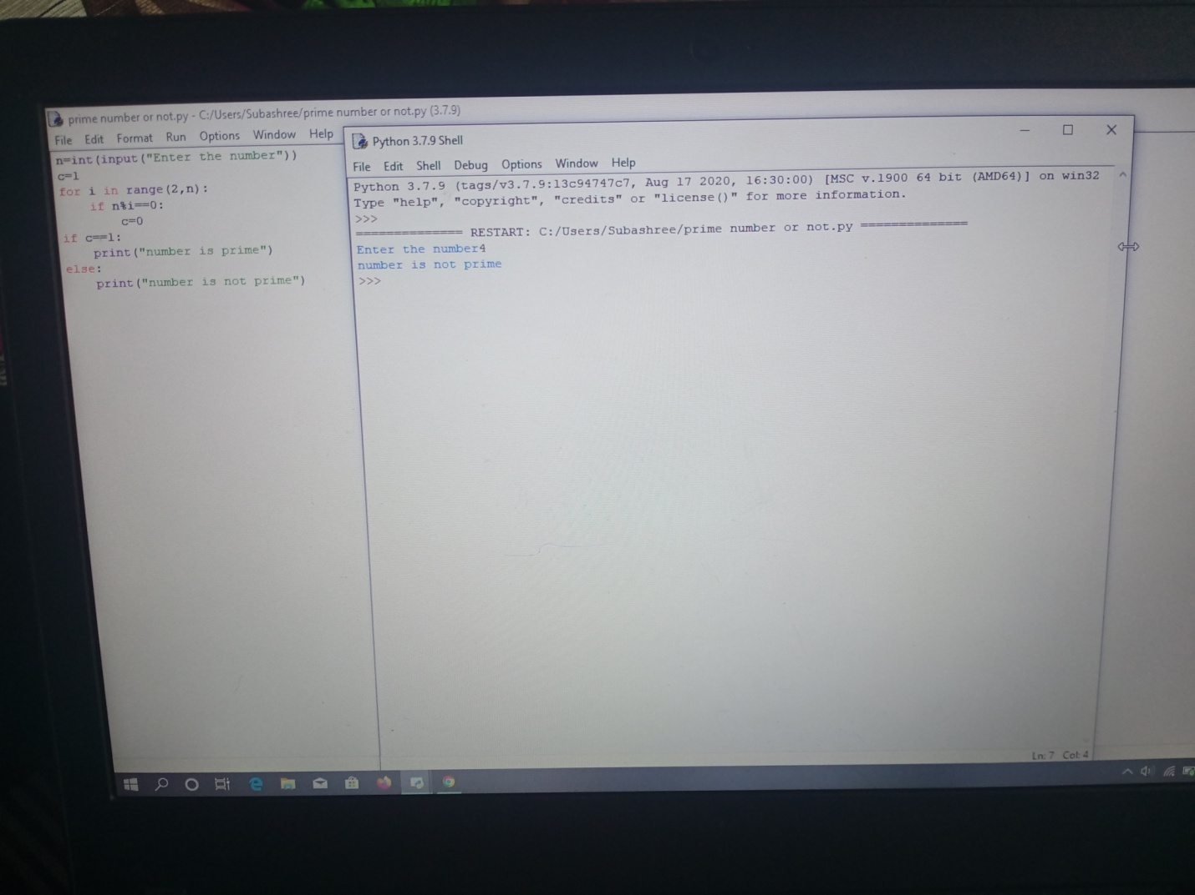

2.Write a program to generate a odd numbers from m to n using while loop.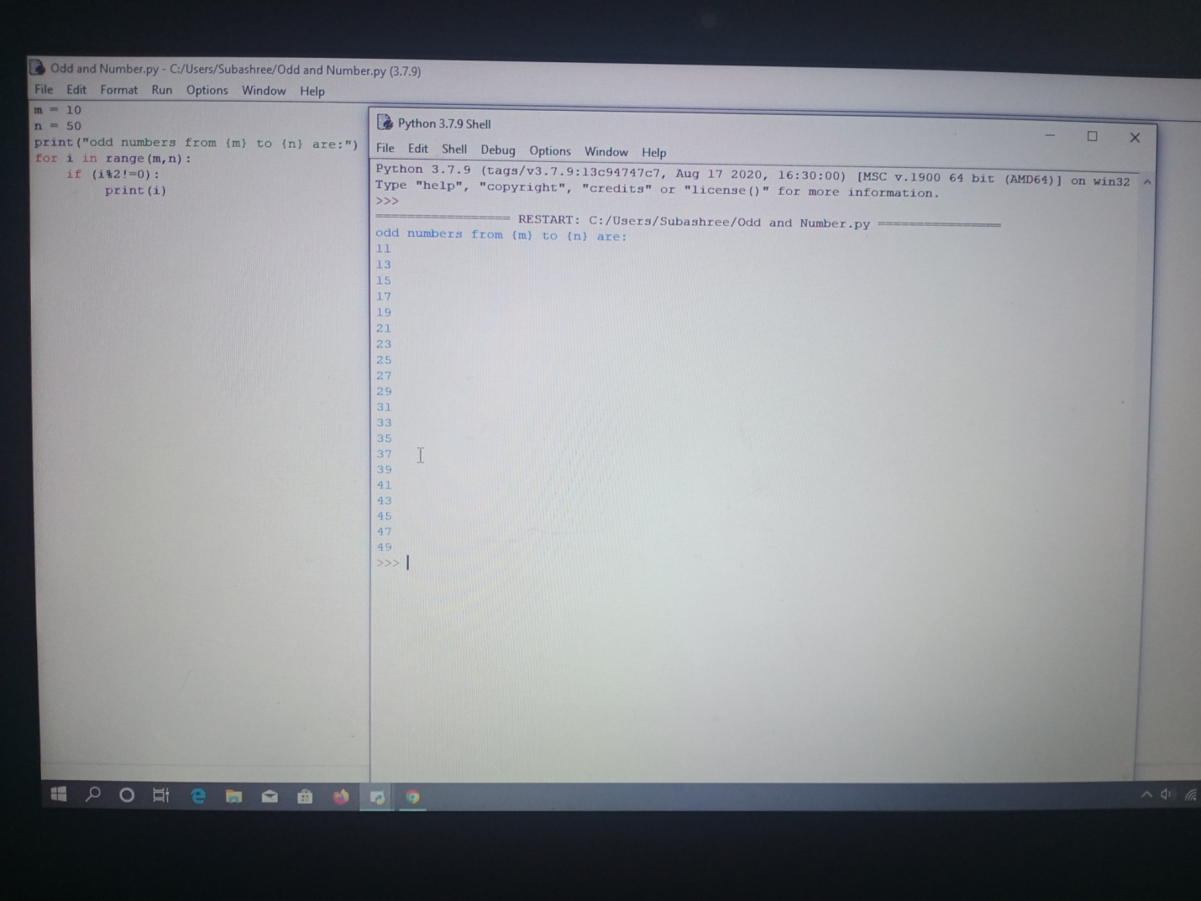

3.Write a Python program to display prime number series up to given number.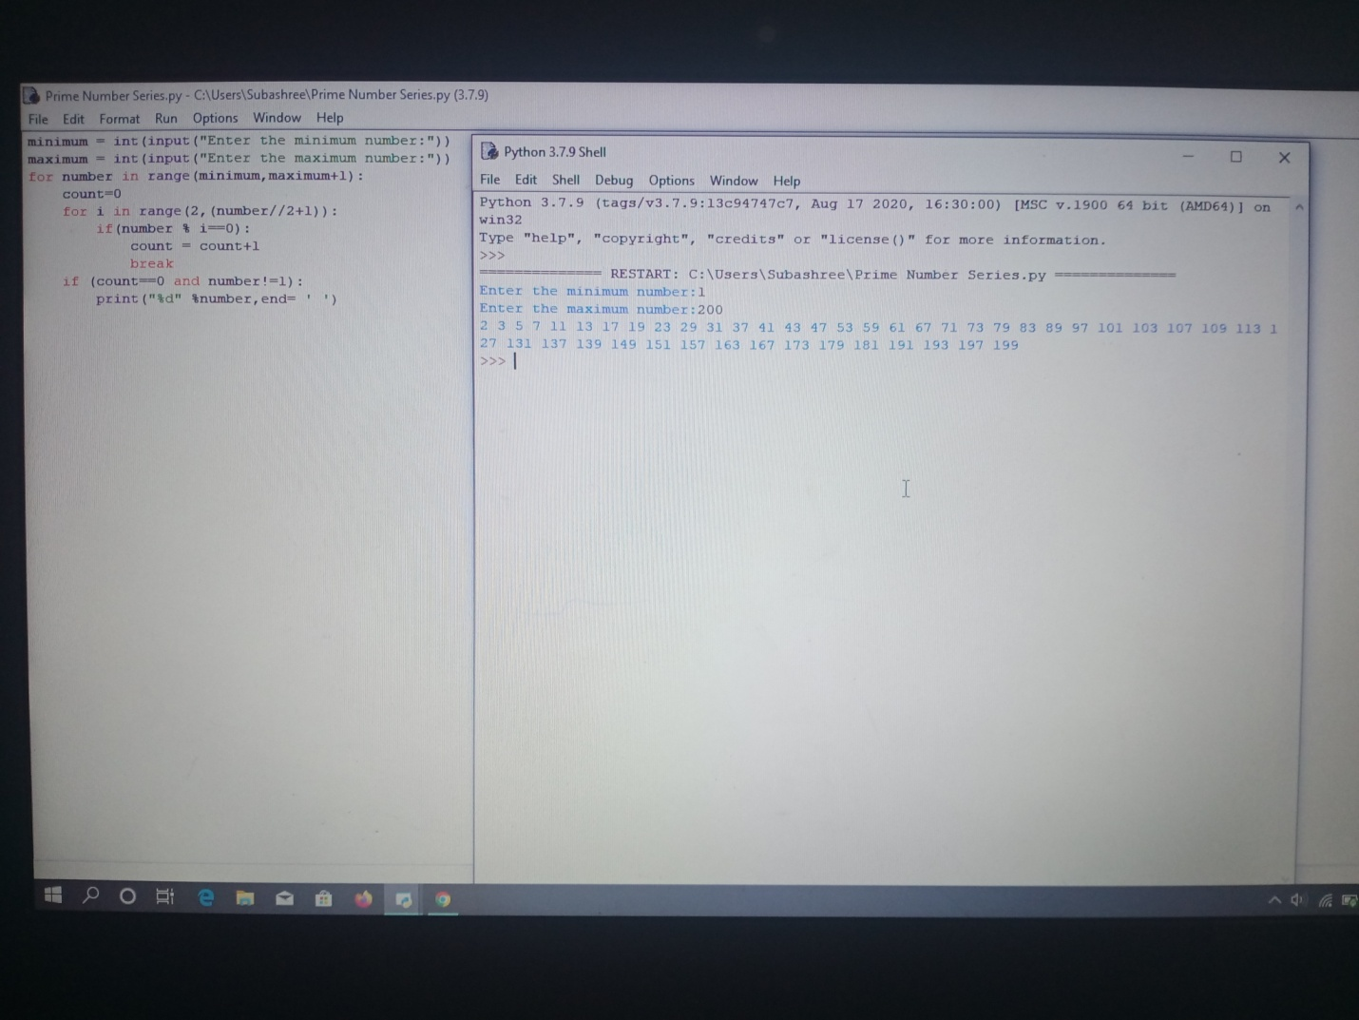

4.Write a Python program to generate Fibonacci series.